**Crestron Certified Integrated Partner Module: Fader Control v2.0**

**Models:** Symetrix Integrator Series; 722, 760, 761, 780, 788. Jupiter Series; J4, J8, J12. SymNet; 8x8 DSP, Express Cobra DSP, Solus DSP, Edge DSP, Radius DSP.

**Device Type:** Audio Mixer, DSP.

**General Information**

The SymNet Certified Integrated Partner Module called SymNet Fader Control v2.0 is much like the module Fader Control v1.0. The main difference is that the SIMPL + (Fader Processor v1.0) file which must be used to get Fader Control v2.0 to work uses a CS (Controller Set Command) instead of the original Fader Processor file which used a CSG (Controller Set Global) command. There are fields available in the module for the touch panel variable which represents the analog slider as well as increment and decrement volume fields. The integrator may comment these out. There is also a location in which to put the SymNet Controller Number associated with the gain stage.

**Category:** Mixer, Audio DSP.

**Version:** 2.0

**Summary:**

This module is meant to control any gain stage in any SymNet DSP. It operates when given the variable from a Crestron touch-panel slider and converts and transmits the analog signal from the slider variable to serial string signal that will operate on a SymNet Controller number through a scale of (0) to (65,535).

**General Notes:**

The SymNet Fader Control v2.0 module is comprised of a SIMPL + module (Fader Processor v1.0) wrapped in a SIMPL module shell. Be sure to put both files into your directory, save and compile them. The majority of SymNet gain stages are 84dB; -72dB to +12dB. The SymNet Control Protocol associates a value scale from (0) to (65,535) with the each Controller Number. The Fader Processor v1.0 that comes in this v2.0 download is using a CS (Controller Set) command instead of the CSG (Controller Set Global) command that was used by the v1.0 modules. Be sure to use the 2.0 modules when programming the SymNet Composer based DSP; Edge and Radius. Edge and Radius do not respond to Global commands.

It is worth reading the SymNet Control Protocol document for the Series to which you wish to communicate with using this module. The SymNet Control Protocol is identical for each series. The factor to consider is whether the SymNet Controller Numbers have already been assigned; as in the case of Jupiter, or Integrator Series, or do you need to assign the SymNet Controller Numbers yourself. Open architecture DSP such as the 8x8 DSP, Express Cobra, Solus, Edge and Radius have an open architecture and thus the SymNet Controller Numbers are assigned by the integrator at the time of design.

**Crestron Hardware Required:**

2 or 3 Series. RS-232, or UDP card required.

**Setup of Crestron Hardware:**

*RS-232.* Baud Rate; 38400 to 115200 - Configurable through SymNet Software Application. 8 Bit, Non-Parity, Stop Bit; 1, Flow Control; None.

*Crestron Cable Type.* CNSP-121

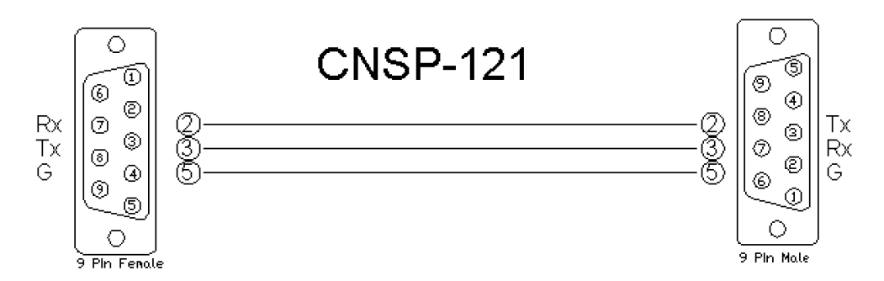

*UDP/IP.* Port: 48630.

**Application Notes:**

This Fader Control v2.0 module is compatible with all SymNet Software and unit Firmware versions. Those DSP which are programmed with SymNet Designer; 8x8 DSP, Express Cobra, Solus units, used the Legacy architecture of Numbered Rings and Unit Address Numbers within those rings. Those DSP which are programmed with SymNet Composer; Edge and Radius, use Dante to transmit digital audio and control between units. The Edge and Radius DSP will not respond to the Version 1 Crestron Integrated Partner Modules. Use the Version 2 modules when working with Edge and Radius DSP. These units will only respond to the CS Controller Set command used in the Version 2 modules. They do not respond to the CSG Controller Set Global command. This is due to the fact that the concept of the SymLink ring has gone away.

The Integrator will designate the parameter to be controlled in the SymNet DSP by using the "right-click" menu in SymNet Composer and assigning an RS-232/485 SymNet Controller Number to the gain stage they wish to control. There are up to 9,999 SymNet Controller Numbers that can be assigned within the DSP system. The scale of value for each SymNet Controller Number is 0 to 65,535.

Be sure to add, save and compile both Fader Processor v1.0 and Fader Control v2.0 into the SIMPL project directory. The Fader Processor makes use of the Fader Control SIMPL + module to generate it's values. Be sure that the analog variable used for the slider input is associated with an analog join that is actually assigned to a slider. The "Slider" is the Crestron fader drawing, not a gauge. The integrator may want to make sure to enable push on the SymNet Controller Number that is assigned to the gain stage. If the gain stage is changed by another controller, you would want its state/level to be reflected on the touch-panel.

**Module Graphic:**

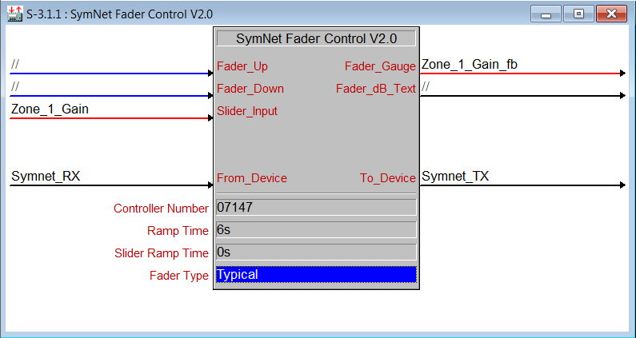

**Control:**

*Fader_Up.* Signal Type: Digital. A button press which will cue the raising of the volume gain stage. *Fader_Down.* Signal Type: Digital. A button press which will cue the lowering of the volume gain stage. *Slider_Input.* Signal Type: Analog. This will be the touch-panel variable for the slider that is drawn.

**Parameters:**

*Controller_Number.* Signal Type: Variable to be entered by the Integrator. This will be the SymNet Controller Number that is assigned to the gain stage.

*Ramp_Time.* Signal Type: Variable to be entered by the Integrator. A ramp time inseconds associated with pressing and holding high the Volume UP and Volume Down stepped controls.

*Slider Ramp Time.*  Signal Type: Variable to be entered by the Integrator. A ramp time in seconds associated with the analog slider variable.

*Fader Type.*  Signal Type: Variable to be entered by the Integrator. A parameter allowing a pull-down menu which will associate a 48dB, a 72dB, or a 96dB scale.

**Feedback:**

*From_Device.* Signal Type: Serial. This is the serial string information coming from the SymNet DSP into the Crestron system module.

**Testing:**

*SymNet OS.* SymNet Designer v10.06, SymNet Composer v1.1, Jupiter Software v2.0.1.12, Integrator Series 761 Software v2.01. *SIMPL OS.* 4.01 *Crestron DB.* 35.00.004.00